Data Structure and Algorithm
Laboratory Activity No. 14

Tree Structure Analysis

Submitted by: | Instructor:
Caasi, Karl Benedict D. | Engr. Maria Rizette H. Sayo

November 08, 2025

Objectives
Introduction
An abstract non-linear data type with a hierarchy-based structure is a tree. It is made up of links connecting nodes (where the data is kept). The root node of a tree data structure is where all other nodes and subtrees are connected to the root.

This laboratory activity aims to implement the principles and techniques in:
- To introduce Tree as Non-linear data structure
- To implement pre-order, in-order, and post-order of a binary tree
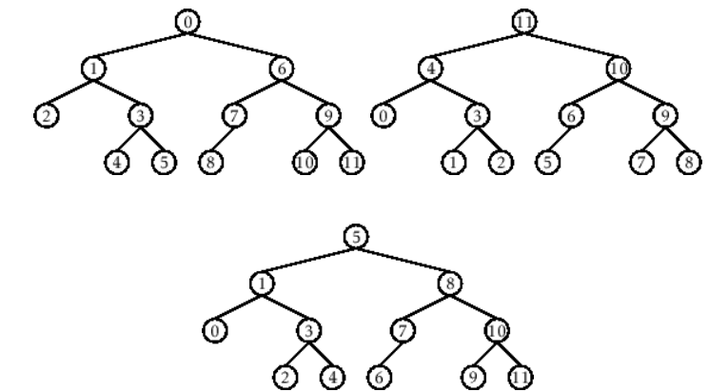

- Figure 1. Pre-order, In-order, and Post-order numberings of a binary tree

Methods
  - Copy and run the Python source codes.
  - If there is an algorithm error/s, debug the source codes.
  - Save these source codes to your GitHub.
  - Show the output

    - Tree Implementation

class TreeNode:
def __init__(self, value):
self.value = value
self.children = []

def add_child(self, child_node):
self.children.append(child_node)

def remove_child(self, child_node):
self.children = [child for child in self.children if child != child_node]

def traverse(self):
nodes = [self]
while nodes:
current_node = nodes.pop()
print(current_node.value)
nodes.extend(current_node.children)

def __str__(self, level=0):
ret = " " * level + str(self.value) + "\n"
for child in self.children:
ret += child.__str__(level + 1)
return ret

# Create a tree
root = TreeNode("Root")
child1 = TreeNode("Child 1")
child2 = TreeNode("Child 2")
grandchild1 = TreeNode("Grandchild 1")
grandchild2 = TreeNode("Grandchild 2")

root.add_child(child1)
root.add_child(child2)
child1.add_child(grandchild1)
child2.add_child(grandchild2)

print("Tree structure:")
print(root)

print("\nTraversal:")
root.traverse()

Questions:
- What is the main difference between a binary tree and a general tree?
- In a Binary Search Tree, where would you find the minimum value? Where would you find the maximum value?
- How does a complete binary tree differ from a full binary tree?
- What tree traversal method would you use to delete a tree properly? Modify the source codes.

Results
Present the visualized procedures done. Also present the results with corresponding data visualizations such as graphs, charts, tables, or image . Please provide insights, commentaries, or explanations regarding the data. If an explanation requires the support of literature such as academic journals, books, magazines, reports, or web articles please cite and reference them using the IEEE format.
Please take note of the styles on the style ribbon as these would serve as the style format of this laboratory report. The body style is Times New Roman size 12, line spacing: 1.5. Body text should be in Justified alignment, while captions should be center-aligned. Images should be readable and include captions. Please refer to the sample below:
1. What is the main difference between a binary tree and a general tree?

Binary Tree: Each node has at most two children (commonly called left and right).
General Tree: Each node can have any number of children (zero or more).

2. In a Binary Search Tree, where would you find the minimum value? Where would you find the maximum value?

- Minimum value: Found at the leftmost node (keep going left until no more left child).
- Maximum value: Found at the rightmost node (keep going right until no more right child).

3. How does a complete binary tree differ from a full binary tree?

Complete Binary Tree: All levels are fully filled except possibly the last, which is filled from left to right without gaps.
Full Binary Tree: Every node has either 0 or 2 children (no nodes with only one child).

4. What tree traversal method would you use to delete a tree properly? Modify the source codes.

Post-order traversal is used to delete a tree properly because it deletes the children before deleting the parent node.
You should modify the traversal to visit children first, then process the node.

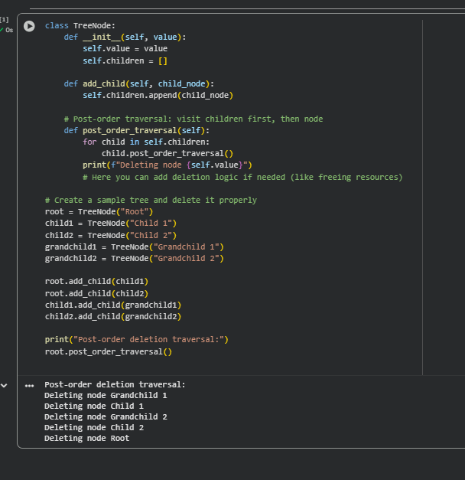
CONCLUSION
- Knowing how different trees work is important in computer science. A binary tree lets each node have up to two children, while a general tree can have many children per node. In a Binary Search Tree (BST), the smallest value is found by going all the way left, and the largest by going all the way right, which helps with quick searching. A complete binary tree fills every level from left to right without missing spots, but a full binary tree makes sure every node has either zero or two children. When deleting a tree, using post-order traversal is best because it deletes all child nodes before the parent, avoiding leftover or “orphan” nodes.
REFERENCE
Cormen, T. H., Leiserson, C. E., Rivest, R. L., & Stein, C. (2009). Introduction to Algorithms (3rd ed.). MIT Press.
- Weiss, M. A. (2013). Data Structures and Algorithm Analysis in C++ (4th ed.). Pearson.
- GeeksforGeeks. (n.d.). Tree Data Structure. Retrieved from https://www.geeksforgeeks.org/binary-tree-data-structure/
- Kleinberg, J., & Tardos, É. (2005). Algorithm Design. Pearson.

